

**Chittagong University of Engineering and Technology**

**Department of Electrical and Electornic Engineering**

Course no: EEE 242

Course title: Electronic Shop Practice

**FINAL PROJECT:**

**MAZE SOLVING ROBOT**

**SUBMITTED BY :**

* Evan Modak Arup ( ID: 1702074)
* Pinak Shadhu Khan (ID: 1702101)
* Riad Al Mahmud( ID: 1702107)
* Kawshik Nath(ID: 1702121)

**SUBMITTED TO:**

Naqib Sad Pathan

lecturer

Department of Electrical and Electornic Engineering

CUET

***Abstract:***

Autonomous navigation is an important feature that allows a mobile robot to independently move from a point to another without an intervention from a human operator. Autonomous navigation within an unknown area requires the robot to explore, localize and map its surrounding.

By solving a maze, the pertaining algorithms and behavior of the robot can be studied and improved upon. This paper describes an implementation of a maze-solving robot designed to solve a maze based on the flood-fill algorithm. Detection of walls and opening in the maze were done using ultrasonic range-finders. Algorithm for straight-line correction was based on PI(D) controller. The robot was able to learn the maze, find all possible routes and solve it using the shortest one.

***INTRODUCTION:***

In mobile robotics, autonomous navigation is an important feature because it allows the robot to independently move from a point to another without a tele-operator. Numerous techniques and algorithms have been developed for this purpose, each having their own merits and shortcomings .

Maze-solving – although artificial in terms of the confine that the robot it subjected to – is a structured technique and controlled implementation of autonomous navigation which is sometimes preferable in studying specific aspect of the problem . This paper discusses an implementation of a small size mobile robot designed to solve a maze based on the flood-fill algorithm.

The maze-solving task is similar to the ones in the MicroMouse competition where robots compete on solving a maze in the least time possible and using the most efficient way. A robot must navigate from a corner of a maze to the center as quickly as possible. It knows where the starting location is and where the target location is, but it does not have any information about the obstacles between the two. The maze is normally composed of 256 square cells, where the size each cell is about 18 cm × 18cm. The cells are arranged to form a 16 row × 16 column maze. The starting location of the maze is on one of the cells at its corners, and the target location is formed by four cells at the center of the maze. Only one cell is opened for entrance.

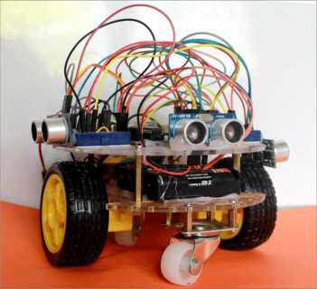

FIG NO 01: A MAZE SOLVING ROBOT

***COMPONENT LIST:***

* Soft plastic sheet
* Hard plastic sheet
* Ultrasonic sensor
* Arduino Uno
* Jumper wire
* Lithium battery(upto 11v)
* Glue gun
* Motor driver
* 6v motor
* Wheel
* Switch

***COMPONENT DESCRIPTION:***

* **SOFT PLASTIC SHEET:**

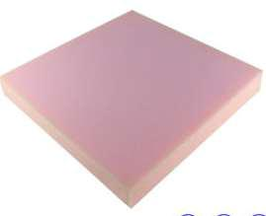

It has been used to build the maze

* **Hard plastic sheet:**



It has been used for the robot body.It is hard enough to take the weight of others component of the robot

* **Ultrasonic sensor:**

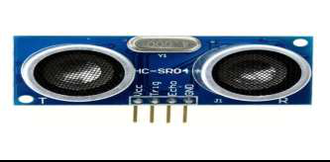

Ultrasonic transducers or ultrasonic sensors are a type of acoustic sensor divided into three broad categories: transmitters, receivers and transceivers. Transmitters convert [electrical](https://en.wikipedia.org/wiki/Signal_(electrical_engineering)) [signals](https://en.wikipedia.org/wiki/Signal_(electrical_engineering)) into [ultrasound,](https://en.wikipedia.org/wiki/Ultrasound) receivers convert ultrasound into electrical signals, and transceivers can both transmit and receive ultrasound.

In a similar way to [radar](https://en.wikipedia.org/wiki/Radar) and [sonar,](https://en.wikipedia.org/wiki/Sonar) ultrasonic [transducers](https://en.wikipedia.org/wiki/Transducer) are used in systems which evaluate targets by interpreting the reflected signals. For example, by measuring the time between sending a signal and receiving an echo the distance of an object can be calculated. Passive ultrasonic sensors are basically microphones that detect ultrasonic noise that is present under certain conditions.

* **Arduino Uno:**

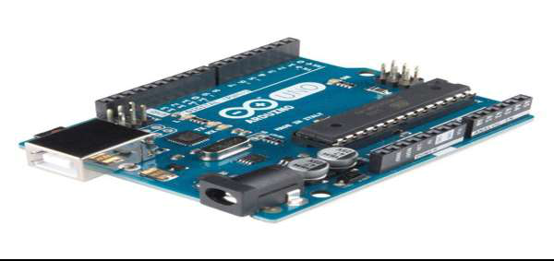

The Arduino Uno is an open-source microcontroller board based on the Microchip ATmega328P microcontroller and developed by Arduino.cc. The board is equipped with sets of digital and analog input/output (I/O) pins that may be interfaced to various expansion boards (shields) and other circuits. The board has 14 digital I/O pins (six capable of PWM output), 6 analog I/O pins, and is programmable with the Arduino IDE (Integrated Development Environment), via a type B USB cable. It can be powered by the USB cable or by an external 9-volt battery, though it accepts voltages between 7 and 20 volts. It is also similar to the Arduino Nano and Leonardo. The hardware reference design is distributed under a Creative Commons Attribution Share-Alike 2.5 license and is available on the Arduino website. Layout and production files for some versions of the hardware are also available.

The word "uno" means "one" in Italian and was chosen to mark the initial release of Arduino Software.The Uno board is the first in a series of USB-based Arduino boards. It and version 1.0 of the Arduino IDE were the reference versions of Arduino, which have now evolved to newer releases. The ATmega328 on the board comes preprogrammed with a bootloader that allows uploading new code to it without the use of an external hardware programmer.

* **Jumper wire:**

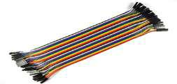

A jump wire (also known as jumper wire, or jumper) is an electrical wire, or group of them in a cable, with a connector or pin at each end (or sometimes without them – simply "tinned"), which is normally used to interconnect the components of a breadboard or other prototype or test circuit, internally or with other equipment or components, without soldering**.**

* **Lithium battery:**

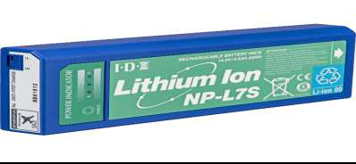

A lithium-ion battery or Li-ion battery (abbreviated as LIB) is a type of rechargeable battery. Lithium-ion batteries are commonly used for portable electronics and electric vehicles and are growing in popularity for military and aerospace applications.

In the batteries lithium ions move from the negative electrode through an electrolyte to the positive electrode during discharge, and back when charging. Li-ion batteries use an intercalated lithium compound as the material at the positive electrode and typically graphite at the negative electrode. The batteries have a high energy density, no memory effect (other than LFP cellsand low self-discharge. They can however be a safety hazard since they contain a flammable electrolyte, and if damaged or incorrectly charged can lead to explosions and fires. Samsung were forced to recall Galaxy Note 7 handsets following lithium-ion fires.

* **Glue gun:**

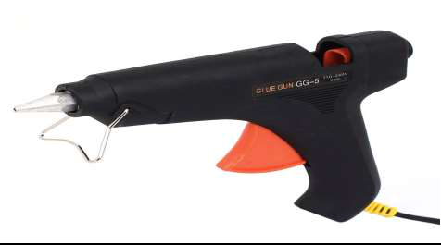

Used to attached the sheet to build the maze and used for to attached the components with the base of the body

* **Motor driver:**

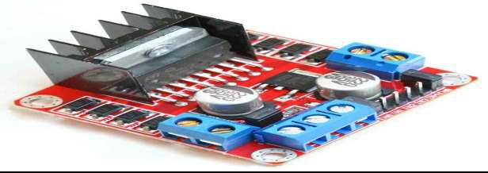

A motor controller is a device or group of devices that serves to govern in some predetermined manner the performance of an [electric motor.](https://en.wikipedia.org/wiki/Electric_motor) A motor controller might include a manual or automatic means for starting and stopping the motor, selecting forward or reverse rotation, selecting and regulating the speed, regulating or limiting the torque, and protecting against overloads and [faults.](https://en.wikipedia.org/wiki/Fault_(power_engineering))

* **6v motor:**

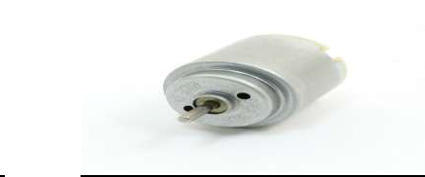

It has been used to run the robot

* **Wheel :**

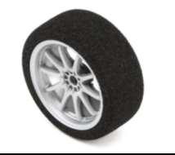

and we also use switch for just on and off the robot.

***Updating The Wall Data:***

Before the robot decides where it wants to move to, it has to check if it is surrounded by any walls in any of the three directions: right, left and front. The robot reads the distance of any obstacle at each direction and check if the distance in each is more than 20 cm. The ones that exceed 20 cm are updated as “wall” on their respective side. This is illustrated by the flow chart . For the robot to update the correct wall data, it has to know first which direction it is facing. There are four orientations for the robot to be facing: north, south, east or west, as shown in Figure 6. Initial orientation was set at start and the robot keeps tracking of any changes.

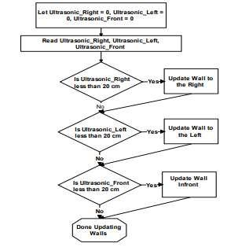

FIG NO 02: Flowchart for updating wall location

***Procedure:***

1. For the construction of maze solving robot firstly we have to make the structure of the outer surface. Then connect the parts with glue gun.
2. After connecting the four wheel with the motor we attached them with the plastic wood and ultrasonic sensors were connected accordingly.
3. We connected in the outer surface Arduino, ultrasonic sensors, motor driver, motor with wheels.
4. The function of L298N motor driver is to run the motors.
5. According to the codes being uploaded to Arduino the ultrasonic sensors will work accordingly.
6. The function of the ultrasonic sensor is to detect the obstacles around and move in a way where there is no obstacle prevailing.
7. We are giving a power supply from 1100 mAh rechargeable battery along which switch is connected.
8. Along with the switch being on the power supply will start.
9. Arduino will take a supply of 12 volts and sensors will receive 5 volts each.

***HARDWARE DESIGN:***

The robot has a length of 15 cm, a width of 8 cm and a height of 6 cm. As illustrated in Fig 1, the robot is equipped with three ultrasonic distance sensors facing front, left and right to scan the area ahead for obstacles and specifically to detect for walls. A wheel rotation encoder is placed near each wheel so that the extend of how much the wheel is rotating can be detected. With the diameter of the wheel is known, the rotation can converted into distance traveled.

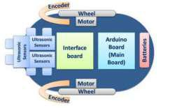

FIG NO 03: HARDWARE DESIGN

***Simulation:***

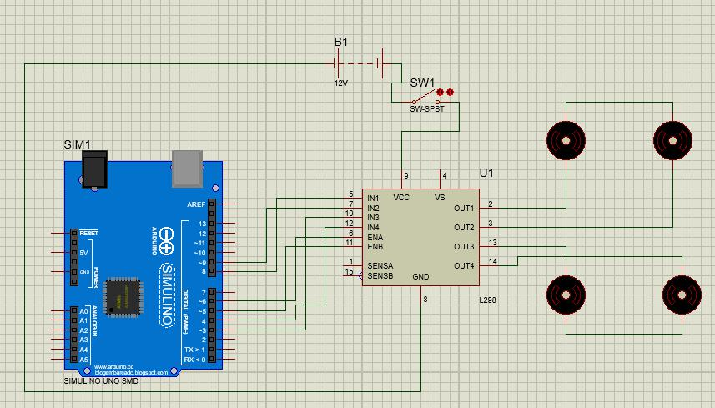

***FLOW CHART OF THIS PROJECT:***

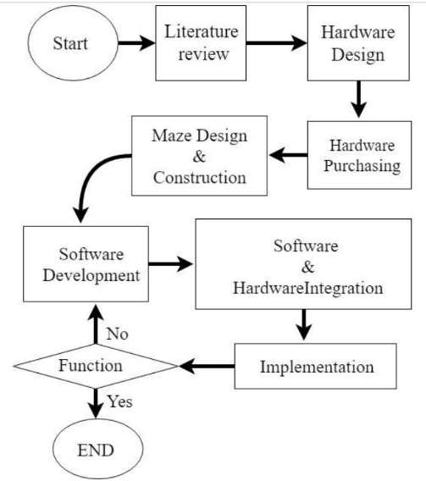

***OUR FINAL PROJECT:***

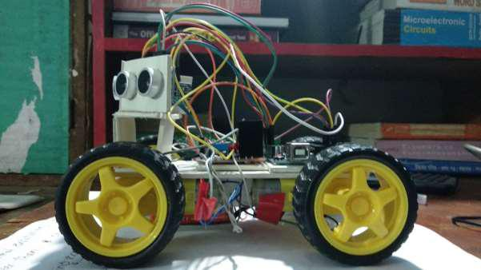

***COST ANALYSIS:***

* soft plastic sheet- 100*3=300
* hard plastic sheet-130=130
* ultasonic sensor- 150*3=450
* arduino uno-400=400
* motor driver-130=130
* jumper wire=20(per dozen)=20
* 6v motor- 130*4=520
* Wheel= 100*4=400
* Glue gun (small)-200=200
* Switch-5=5
* Lithium battery-850=850

Total cost was=3405

***APPLICATION:***

Nowadays robots are widely used in various critical and dangerous find. This project is based on decision making algorithms. So, it can be used in various intelligent fields. It can be used as a rescue operation, navigation problems, search operation, medical attention, military search and rescue, etc. There are many caves that are like mazes where humans could get lost in. This robot can find its way out again. It can also be used in too small or dangerous cave where human can’t enter.

***CONCLUSION:***

As a conclusion, the two mazes solving algorithm have successfully been implemented in the robot and the objectives of the project have been achieved. The first algorithm was wall following algorithm.

The basic method shows a good result for solving the maze. But, due to lack of self-intelligence, it failed to solve the maze in the shortest way. And it could not solve to close loop maze. So, an efficient method has been used to find the shortest path that is flood fill algorithm method. After applying all methods, the robot was trained in a real maze. Several tests has been run to ensure the best performance of the robot.

This project helps to improve various important information about robotics, knowledge about many decision making algorithms. It’s also helped to learn about many electronics components such as motor driver, sensors, etc. This gained knowledge will have a significant impact on future work.

***FURTHER DEVELOPMENT:***

This robot is little bit slow, so new method should be developed. The size of the robot can be made smaller. In this project, the ultrasonic sensor is used for mapping the maze. Other efficient navigating sensors can be used. At last, it needs development in its wheels and body to make it comfortable in rough surface.